Socket Programming

Sockets
- Socket is a data communication endpoint for exchanging data over the network
- Uniquely identified by:
- ip address
- ‰end-to-end protocol (e.g. TCP or UDP)‰
- port number
Types of (TCP/IP) Sockets :
Stream Sockets (e.g uses TCP):
- Provides reliable byte-stream service
- Connection oriented
- Data in order
Datagram Sockets (e.g uses UDP):
- Connection less
- Data not in order
- Not reliable

Important Terms
- Socket Creation
- Bind
- Listen
- Accept
- Connect
- Send
- Receive
- Close
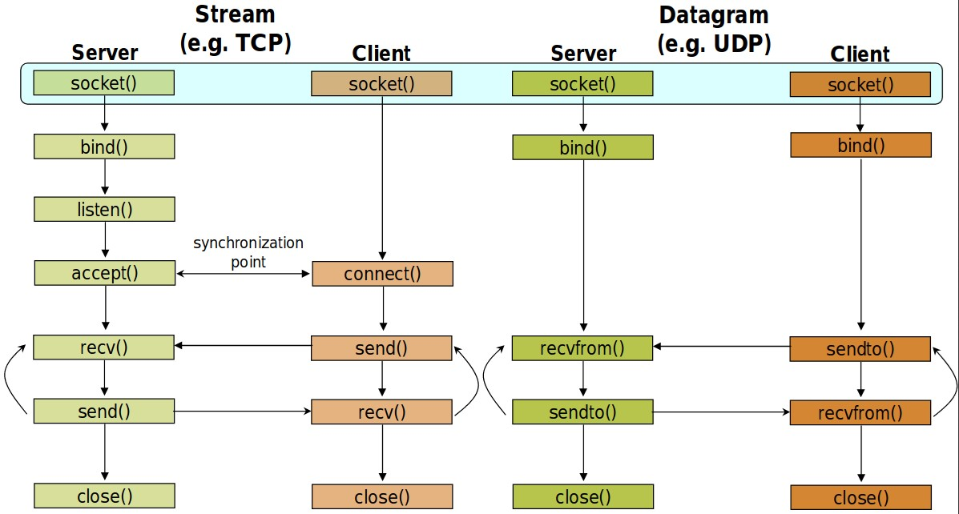

Socket Creation
int sockid = socket(family, type, protocol);
sockid : socket descriptor, an integer (like a file-handle)
Family:
E.g PF_INET IPv4 Internet protocols
More details :
- http://man7.org/linux/man-pages/man2/socket.2.html
Type :Communication Type
SOCK_STREAM
SOCK_DGRAM Protocol :
usually set to 0 (i.e., use default protocol)

Closing
Socket
int status = close(sockid);
- Sockid : descriptor
- status : 0 if successful , -1 if error
Closing a socket:
- Closes a connection (for stream socket) - Frees up the port used by the socket

Bind()
Assign address to socket

struct sockaddr_in{
unsigned short sin_family; /* Internet protocol (AF_INET) */ unsigned short sin_port; /* Address port (16 bits) */ struct in_addr sin_addr; /* Internet address (32 bits) */
};

struct in_addr {
unsigned long s_addr; /* Internet address (32 bits) */
} int status = bind(sockid, &addrport, size);
Example:
int socketfd = socket(PF_INET,SOCK_STREAM,0);
If ( socketfd < 0 ){ cout<<"Error in connection"<<endl;
exit(1);
}
struct sockaddr_in serveraddr; serveraddr.sin_family = AF_INET; serveraddr.sin_port=htons(2000); serveraddr.sin_addr.s_addr=inet_addr("127.0.0.1"); int ret = bind(socketfd , (struct sockaddr*)&serveraddr , sizeof(serveraddr));
If ( ret < 0 ){ cout<<"Error in Binding"<<endl;
exit(1);
}

Listen()

int status = listen(sockid, queueLimit);
queueLimit : No. of active participants that can “wait” for a connection.
Note:
If a connection request arrives when the queue is full, the client may receive an error with an indication of ECONNREFUSED.

Establish Connection: connect()
The client establishes a connection with the server by calling connect()

int status = connect(sockid, &foreignAddr, addrlen);
sockid : socket descriptor, an integer (like a file-handle)
foreignAddr : struct sockaddr: address of the passive participant
Addrlen : size of addr structure

Incoming Connection : accept()
The server gets a socket for an incoming client connection by calling accept()
int new_socket = accept(sockid, &clientAddr, &addrLen); accept() :
is blocking: waits for connection before returning
‰
dequeues the next connection on the queue for socket (sockid)
Exchanging data with stream socket
Send():
int count = send(sockid, msg, msgLen, flags);
sockid : socket descriptor, an integer (like a file-handle) msg : const void[], message to be transmitted
msgLen : length of message flags : integer, special options, usually just 0
Count : Number of bytes transmitted (-1 if error)
More Details :
- https://linux.die.net/man/2/send
Recv():
int count = recv(sockid, recvBuf, bufLen, flags);
sockid : socket descriptor, an integer (like a file-handle) recvBuf: void[], stores received bytes bufLen: # bytes to read flags: # bytes received (-1 if error)
Note:
send() and recv() are blocking‰ returns only after data is sent / received

Exchanging data with datagram socket
Sendto():
int count=sendto(sockid,msg,msgLen, flags,&foreignAddr, addrlen);
sockid : socket descriptor, an integer (like a file-handle) msg : const void[], message to be transmitted

msgLen : length of message
flags : integer, special options, usually just 0 Count : Number of bytes transmitted (-1 if error) foreignAddr :Address of destination
Addrlen : sizeof(foreignAddr)
Recvfrom():
int count = recvfrom(sockid, recvBuf, bufLen, flags,

&clientAddr, addrlen);
sockid : socket descriptor, an integer (like a file-handle) recvBuf: void[], stores received bytes bufLen: # bytes to read flags: # bytes received (-1 if error) clientAddr :Address of destination
Addrlen : sizeof(clientAddr)
Examples (Stream Socket):
1. Send some integer from client to server:
Client Side :
int x = 10;
send(clientSock, &x, sizeof(x), 0);
Server Side :
int x;
recv(serverSock, &x, sizeof(x), 0);
2 . Sending a file:
- Sending Side (client) int sockfd = socket( AF_INET, SOCK_STREAM, 0 );
struct sockaddr_in serv_addr; serv_addr.sin_family = AF_INET; serv_addr.sin_port = htons( PORT ); serv_addr.sin_addr.s_addr=inet_addr("127.0.0.1");
connect ( sockfd , (struct sockaddr *)&serv_addr , sizeof(serv_addr) )
FILE *fp = fopen ( "path of file" , "rb" );
fseek ( fp , 0 , SEEK_END);
int size = ftell ( fp ); rewind ( fp );
send ( sockfd , &size, sizeof(file_size), 0);
char Buffer [ BUFF_SIZE] ; while ( ( n = fread( Buffer , sizeof(char) , BUFF_SIZE , fp ) ) > 0 && size > 0 ){
send (sockfd , Buffer, n, 0 ) memset ( Buffer , '\0', BUFF_SIZE); size = size - n ;
}
fclose ( fp ); close( sockfd)
- Receiving Side (Server) server_fd = socket (AF_INET, SOCK_STREAM, 0);
struct sockaddr_in addr; addr.sin_family = AF_INET; addr.sin_port = htons( PORT ); addr.sin_addr.s_addr=inet_addr(INADDR_ANY);
int addrlen = sizeof(sockaddr)
bind (server_fd , (struct sockaddr *)&addr , sizeof ( addr ) ) listen (server_fd, 3) int sockfd = accept ( server_fd , (struct sockaddr *)&address , (socklen_t*)&addrlen);
FILE *fp = fopen ( "path of file" , "wb" ); char Buffer [ BUFF_SIZE] ; int file_size;
recv(serverSock, &file_size, sizeof(file_size), 0);
while ( ( n = recv( sockfd , Buffer , BUFF_SIZE, 0) ) > 0 && file_size > 0){
fwrite (Buffer , sizeof (char), n, fp)
memset ( Buffer , '\0', BUFF_SIZE); file_size = file_size - n;
}
close( sockfd) close( serverfd) fclose ( fp ); Multithreaded Server
void main(){
…….. ……..
listen ( socketfd , 5 ) while(1){ newsocket= accept( sockfd , (struct sockaddr*)&newAddr , &addr_size); thread RequestThread(serveRequest,newsocket,newAddr);
} }
void serveRequest ( int newsoc , struct sockaddr_in newAddr){ // bla bla bla }

